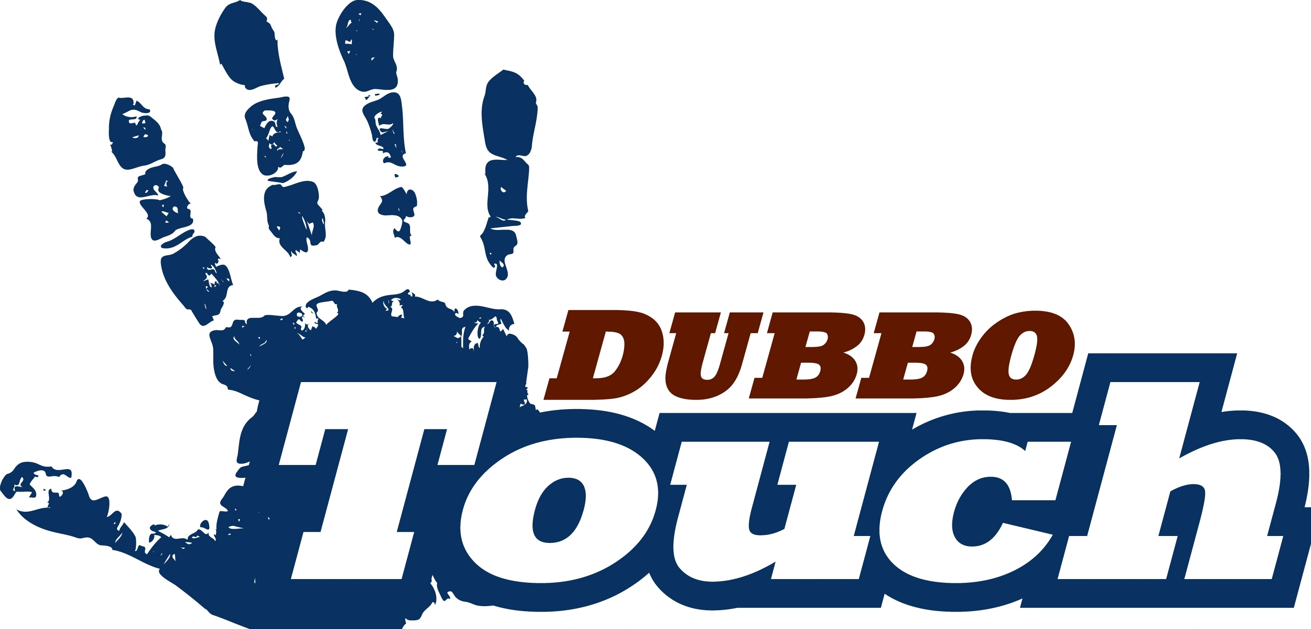

DUBBO TOUCH JUNIOR REP INFORMATION PACK

The Dubbo Touch Junior representative program has significantly developed in recent years with teams having been competitive and achieved success at past tournaments. The Dubbo Touch Junior representative program requires commitment from coaches, players, parents, managers and sponsors, however we encourage all players selected to enjoy themselves in this competitive environment and continue to learn the awesome skills that touch football offers.

This package will provide players and parents with information regarding the 2023/2024 Dubbo Touch representative program including:
- Coaches
- Tournaments
- Payment schedules
- DTA Code of Conduct
- DTA Rep Player and Selection Policy

Dubbo Touch junior rep players are required to adhere to the following commitments:
- Attend all scheduled training sessions
- Be available for tournaments
- Abide by the rep player policy and code of conduct
- Meet all financial commitments

We ask that parents carefully review the information pack and ensure they can assist their child to meet the above commitments prior to registering for Dubbo Touch Junior Rep. If you or your child have any difficulties in meeting these commitments, please contact the Rep Player Coordinator as soon as possible to discuss as failure to do so may jeopardise your child’s position in the team.

In order to express interest for your child in the Dubbo Touch Junior representative program you will need to follow the below process:
- Carefully read this information pack and ensure you and your child are able to meet the commitments
- Ensure you have read and agree to abide by the Code of Conduct and Rep Player and Selection Policy
- Complete the online Dubbo Touch Junior representative program ‘registration to trial’ form by Friday 28 July 2023.

Failure to complete the registration process above will result in your child not being eligible to trial for Dubbo Touch Junior Rep Touch.

If you have any questions please don’t hesitate to give me a call.

Regards

Emma Fitzgerald
DUBBO TOUCH JUNIOR REP PLAYER COORDINATOR
PH: 0419 479 123
COACHES AND MANAGERS

Dubbo Touch is pleased to announce the appointment of Coaches for the 2023/24 representative season.
Division | Coach
U8 Girls | Wade Richardson  Vinnie Williamson (AC)  Amelia Winsley (AC)
U8 Boys | Kurt Fuller  Loch Murphy (AC)
U10 Girls | Mandy Turner  Phoebe Fitzgerald (AC)
U10 Boys | Andrew Tomlins  Alicia Frail (AC)  Ryan Eade (AC)
U12 Girls | Tracey Whillock
U12 Boys | Nic Grose  Bailey Searle (AC)
U14 Girls | Shelley Darcy  Liv Hall (AC)
U14 Boys | Tim Trainor  Andrew Tomlins (AC)
U16 Girls | Emma Fitzgerald  Shannon Smith (AC)
U16 Boys | Harry West  Matt Dawson (AC)  Mitch French (AC)
U18 Girls | Serena Prout

For any initial enquiries players and parents are requested to contact the Rep Player Coordinator.

IMPORTANT - For the 2023/24 representative program Dubbo Touch will again use a single communication medium being the ‘Stack Team App’ for all communication including information about training/trials, updates, uniform purchases, reminders etc. Players and parents should download the Stack Team App, search ‘Dubbo Touch Rep’ and request to become a member of their child/s representative team.

Once the Dubbo Touch Junior representative teams are finalised, Dubbo Touch will call for expressions of interest for 2023/24 managers from Friday 15 September 2023 until Friday 29 September 2023. Parents should strongly consider submission of an expression of interest as every Dubbo Touch Junior representative team will be required to have an allocated manager in order to be deemed eligible to participate in representative tournaments.

Coaches and/or managers will also make contact with parents/guardians of players who register for the Dubbo Touch Junior Representative program.

TOURNAMENTS

Dubbo Touch Junior Rep Teams will be required to attend the following tournaments for 2023/24. The below dates and venues have not been formalized, but we will keep you informed as we get updates.

Don Green Western Junior Championships (Under 8’s – Under 18’s)
18 and 19 November 2023 in Mudgee

Peter Wilson Memorial Championships (Under 10’s – Under 18’s)
3 and 4 February 2024 at Nelson Bay.

NSW Junior State Cup (Under 10’s - Under 18’s)
23, 24 and 25 February 2024 at Dubbo

Please note that coaches may consider attending additional tournament or gala day such as Central Coast Minis Championships (Under 10’s), ACT Junior State Cup (December), Southern Suns Junior Regionals, Wallsend Gala Day (January) etc. Where this is the case an additional costs are likely to apply to cover referee payment and accommodation if required.

TRIALS/SELECTIONS

The Dubbo Touch Junior Representative team trials/selections are proposed to be held on the following dates:
- Sunday 6 August 2023
- Sunday 13 August 2023

Confirmation and specific details around trials will be provided via ‘Stack Team App’ however players should ensure their availability for both trial dates.

Dubbo Touch strongly encourages players looking to be selected in representative teams to attend trial/selection dates to give themselves the best opportunity to be observed and considered. Players must attend a minimum of 1 selection trial and where a player cannot attend a selection trial, a letter/email must be provided explaining the player’s absence to the Rep Player Coordinator before the commencement of the trial in order to be considered for selection in a team.

Player’s trialing for Dubbo Touch Junior Representative teams will need to wear a numbered playing singlet or shirt during the trials/selections and the colour and number will needed to be included in the junior rep player registration form. It is recommended players use their 2022 junior competition playing singlet in the first instance. No representative singlets or shirts are permitted.

The Dubbo Touch Junior Representative Teams is an elite program which requires significant commitment and dedication. Player’s trialing must understand this commitment and be prepared to attend all training sessions and make themselves available for tournaments. The Dubbo Touch Representative Player and Selection Policy provide further information on the selection process.

TRAINING

It is an expectation of players selected in Dubbo Touch Junior Representative Teams that they will commit to attend all training sessions. Representative touch is a significant step up and competitive for selection and therefore requires commitment and dedication from coaches, players and parents. Players who fail to attend training sessions without notifying the coach and without having a sufficient reason will place their position in the representative team in jeopardy.

The Dubbo Touch Under 10 – Under 18 teams will train a minimum 2 sessions per week from September to January and 2-3 sessions per week in February. The Dubbo Touch Under 8 teams will only train one day a week from August to November.

All Dubbo Touch representative teams will train on a Sunday afternoon between 3pm and 6.30pm with coaches to determine additional training days in coming months.

REGISTRATION AND CONSENT

A parent/guardian must register their child for Dubbo Touch Junior Representative Teams by completing the online google doc ‘Dubbo Touch Junior Rep Player Registration Form’ by Friday 28 July 2023. The form will require a parent/guardian to provide consent and agree to abide by the Code of Conduct and Dubbo Touch Junior Rep Player and Selection Policy. This online registration form must be completed by the due date for your child to be eligible for selections/trials.

Please note that any children wishing to play representative touch must be currently or intend to register in the 2023 Dubbo Touch Junior Competition, the 2023 Dubbo Touch Winter Competition, 2023/2024 Dubbo Touch Summer Mixed or Men’s Competition or 2023 Dubbo Touch Spring Women’s Competition to be eligible.

Once selections of the Dubbo Touch Junior Representative teams have been finalised. Parents of the successful players will receive an email offering their child a position in the team. Parents will be required to accept or decline the position in the representative team by Friday 25 August 2023.

COSTS

Dubbo Touch Junior Rep Player Levy

Under 10 – Under 18 Dubbo Touch Junior Rep Player Levy $145 (includes Don Green, Peter Wilson and Junior State Cup)

Under 8 Dubbo Touch Junior Rep Player Levy - $35 (includes Don Green Junior Championships)

Development Team Dubbo Touch Junior Rep Player Levy - $35 (includes Don Green Junior Championships)

The Dubbo Touch Junior Rep Player Levy covers referee/coach payments, referee/coach accommodation, renewal of playing singlet uniforms, training equipment contribution, end of season awards and presentation etc. Due to the extensive fundraising efforts of the Dubbo Touch committee and representative parents in the running of the canteen at the 2023 NSW Touch Junior State Cup, Dubbo Touch has been fortunate to significantly subsidise the rep player levy in 2023/2024.

Please note that coaches may opt for their representative team to attend an additional tournament or gala day during the season. Where this is the case an additional Rep Player Levy is likely to apply to cover referee payment and accommodation if required.

In order to nominate a representative team in a tournament the ‘conditions of entry’ must be met which includes each team having an appropriately qualified coach and referee as well as one additional referee per Association. The Dubbo Touch Officiating Payment Guidelines and Financial Support located on the Dubbo Touch website under ‘representative’ outlines referee and coach payments as well as financial support opportunities.

The Dubbo Touch Junior Rep Player Levy will be payable by those players successfully selected in a Dubbo Touch Junior Representative team via Stack Team App by Friday 6 October 2023 in order for your child to hold their position in the team. To make payment of the DTA Rep Player Levy parents/guardians will be required to go to ‘Stack Team App’, select ‘Dubbo Touch’, select ‘Store’ select appropriate ‘Rep Player Levy’.

Tournament Registration Fee

For each tournament there will be an online registration fee that is set by Hunter /Western Hornets (approx. $50 Don Green and $70 Pete Wilson Junior Champs) or NSW Touch (approx. $120 for Junior State Cup). All parents are responsible for registering their child and will be advised when to do so by your team manager through the ‘Stack Team App’.

Travel and Accommodation

Travel and accommodation for the tournaments will be the responsibility of parents, however, if you are requiring assistance you are to speak to your team’s manager to discuss.

UNIFORM

Dubbo Touch has a three year agreement (2021/2022 – 2023/2024) with Struddy’s for the supply of uniform. Dubbo Touch will supply all representative players with playing singlets which will be required to be handed back at the end of the last game in each tournament to ensure the full set remains together.

Players successfully selected in a Dubbo Touch Junior Representative team will be required to purchase a mandatory uniform which will include: (if they do not already have the uniform from 2021/2022 or 2022/2023 seasons):

ITEM | APPROX COSTS
Playing Shorts | $35
Off Field Playing Shirt | $50
Socks | $15
Hat/ Visor | $15

Dubbo Touch is proposing to introduce a training singlet for the 2023/2024 junior representative season. The singlet is $35 however sponsorship is being sought to reduce the cost.

Players and parents/guardians will also have an opportunity to purchase optional uniforms and merchandise including:

ITEM | APPROX COSTS
Playing Tights | $50
Spectator Shirt | $50
Budgy Smuggler Bucket Hat | $40

Once team selections/trials have been completed parents/guardians will be advised of details regarding uniforms ordering. Uniform orders will be required to be completed on ‘Stack Team App’ by Friday 15 September 2023 with collection expected to be on Sunday 8 and 15 October 2023.

JUNIOR REP PLAYER REFEREE PROGRAM

Dubbo Touch is committed to not just developing our up and coming representative player’s skills but also improving their knowledge of the game and their involvement in the sport. As such this year, Dubbo Touch have a mandatory commitment for players in the Under 14 and 16 teams, who will be required to complete a level 1 referee course and as a minimum referee in the junior competition. Badged referees receive a payment of $10 per game in the junior competition and a level 1 referee receives $15 per game in the senior competition. The junior referees will be mentored and supported by the Referee Director. More information and details about this junior representative player referee program will be provided by ‘Stack Team App’.

JUNIOR REP PRESENTATION

The Dubbo Touch Junior Representative presentation day will be held after NSW Touch Junior State Cup however exact date, times and details will be provided on the ‘Stack Team App’ once confirmed.

FURTHER INFORMATION

If you require any further information on the above please contact Emma Fitzgerald, the Dubbo Touch Junior Rep Player Coordinator preferably on email, emma.fitzgerald479123@gmail.com or otherwise 0419 479 123.

